**DAILY ONLINE ACTIVITIES SUMMARY**

|  |  |  |  |  |  |  |  |  |
| --- | --- | --- | --- | --- | --- | --- | --- | --- |
| **Date:** | **22-6-2020** | | | | | **Name:** | **Prajna** | |
| **Sem & Sec** | **8th sem ‘B’** | | | | | **USN:** | **4AL16CS067** | |
| **Online Test Summary** | | | | | | | | |
| **Subject** | | **SMS** | | | | | | |
| **Max. Marks** | | **30** | | **Score** | | | **-** | |
| **Certification Course Summary** | | | | | | | | |
| **Course** | **Introduction to python programming** | | | | | | | |
| **Certificate Provider** | | | **Great learning** | | **Duration** | | | **2hrs** |
| **Coding Challenges** | | | | | | | | |
| **Problem Statement:**1**.** Write a python program to check list contain a sublist.. | | | | | | | | |
| **Status: Completed** | | | | | | | | |
| **Uploaded the report in GitHub**  **GitHub link:** | | | | | **Yes**  **https://github.com/alvas-education-foundation/prajna_k** | | | |
| **If yes Repository name** | | | | | **prajna_k** | | | |
| **Uploaded the report in slack** | | | | | **yes** | | | |

Online Test Details: (Attach the snapshot and briefly write the report for the same)

Certification Course Details: (Attach the snapshot and briefly write the report for the same)

Coding Challenges Details: (Attach the snapshot and briefly write the report for the same)

2) certification course

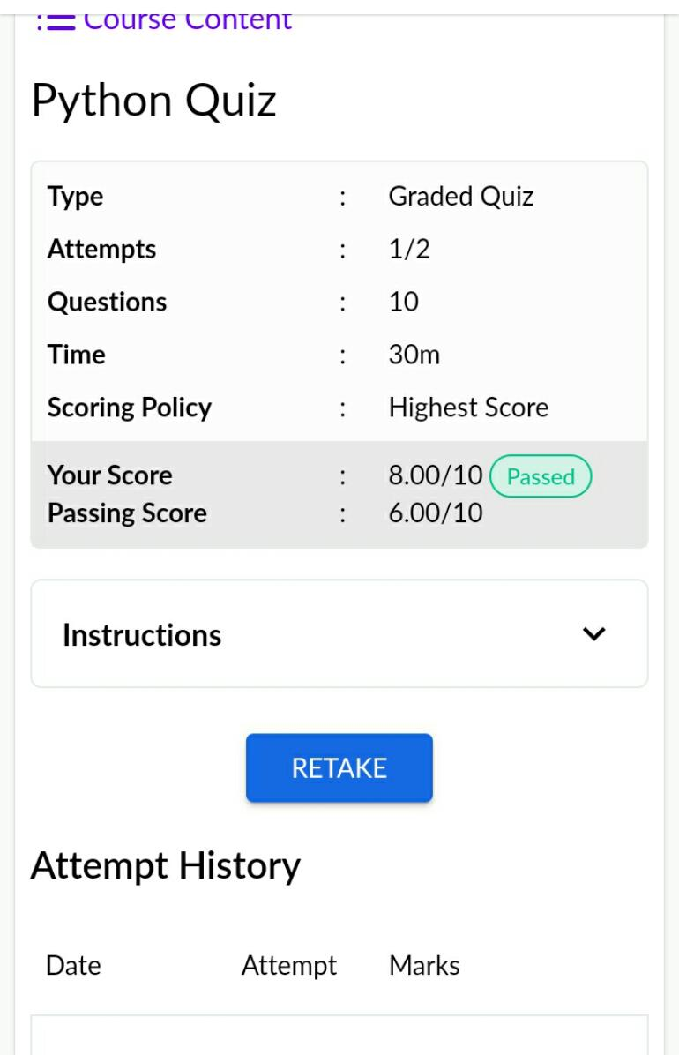

3) coding challenges

def is_Sublist(l, s):

sub_set = False

if s == []:

sub_set = True

elif s == l:

sub_set = True

elif len(s) > len(l):

sub_set = False

else:

for i in range(len(l)):

if l[i] == s[0]:

n = 1

while (n < len(s)) and (l[i+n] == s[n]):

n += 1

if n == len(s):

sub_set = True

return sub_set

a = [2,4,3,5,7]

b = [4,3]

c = [3,7]

print(is_Sublist(a, b))

print(is_Sublist(a, c))

|  |
| --- |
|  |
|  |  |
|  |  |
|  |  |
|  |  |
|  |  |